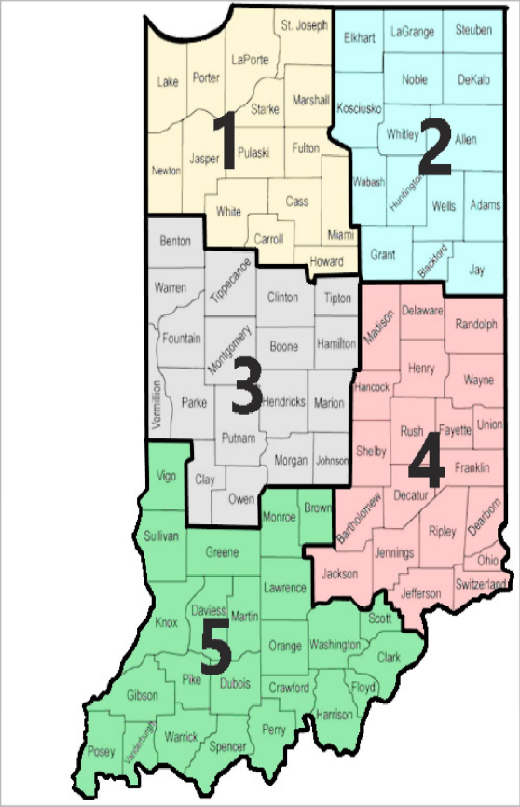

School Year 2026-2027
Region 1: Gordon Food Service
Region 2: Gordon Food Service
Region 3: Gordon Food Service
Region 4: Gordon Food Service
Region 5: Van Eerden

